Step-by-Step: Sharp Shooter Finished Good Returns

| july-20 |

**Document Overview**

**Documentation Goals**

This documentation is intended to provide step by step instructions for ***Returning Finished Good Items using the Sharp Shooter Program****.*

**Table of Contents**

**Overview of Advantzware Specific Keys and Icons** 3

Function Keys 3

Advanced Software Standard Function Keys 4

Program Icons 5

**Sharp Shooter: Finished Goods Returns** 6

Step-by-Step Instructions 6

Step One: Create Negative Release 6

Step Two: Print and Post Bill of Lading 7

Step Three: Print and Post Invoice 8

Step Four: “N”-“K”-“1” BOLPOST Logical Value Inventory Control 9

Step Five: Cycle Count for Returns with Pallet Tags 10

Step Six: Load Tag Creation for Returns without Tags 11

Step Seven: Posting Returns 12

# **Overview of Advantzware Specific Keys and Icons**

## Function Keys

|  |  |
| --- | --- |
| BRWS | The browser, which is a list of records in this file. This is functionally equivalent to the Find option of our standard package. |
| VIEW | View record provides the ability to ADD, CHANGE, DELETE, and UPDATE an individual record. |
| SORT BY | The selections at the bottom of the browser, which will sort the list alphabetic order. |
|  |  |
| Update | Update the current record. |
| Reset | Reset the current record. |
| Add | Add a record. |
| Copy | This will copy the existing record. |
| Delete | Delete the current record displayed on the screen. |
| Cancel | Cancel the information that was entered. |
| Save | Save the record. |
|  |  |
|  | Takes the user to the first current record. |
|  | Moves backward one record. |
|  | Moves forward one record. |
|  | Takes the user to the last current record. |
|  |  |
| F1 | Miscellaneous Fields |
| F3 | Search |
| F3 | List |
| F4 | Notes |
| F6 | Browse |
| F7 | Viewer |
| F12 | Exit |

## Advanced Software Standard Function Keys

|  |  |
| --- | --- |
| Next | Shows the next sequential record. |
| Prev | Shows the previous record. |
| Add | Add a record. |
| Change | Change the current record displayed on the screen. |
| Delete | Delete the current record displayed on the screen. |
| Find | Find a record by searching by description. |
| “1”, “2” | Number 1 or 2 to go the first or second page of this record. |
| Esc | Escape from the current transaction without updating. |
| Q | Quit from the current transaction without updating. |
| F1 | Save |
| F3 | Help information is available on every data field. Simply place the cursor on a field and press F3 to display documentation regarding this particular field. |
| F3 | To insert additional data in a data field without erasing the information currently displayed. |
| F4 | Notes – General |
| F1 | Field Lookup is available on every data field which is maintained in a separate file. Place the cursor on a field and press ***“F1”*** to search for the code by description or to advance a screen of records by pressing the next key. Place the cursor next to the desired record and press enter to transfer the record to the data entry screen. See ***“Page Up”*** / ***“Page Down”*** keys below as an alternative |
| F7 | Delete |
| F8 | Notes – File Specific |
| Enter | Advances the cursor to the next field |
| Page Up | Will skim forward through each record in a data file in sequential order |
| Page Down | Will skim backward through each record in a data file in sequential order |
|  |  |

## Program Icons

|  |  |  |
| --- | --- | --- |
|  | Job Notes |  |
|  | Customer Attachments | Attach files (such as Word/Excel/Images) for this specific customer order. |
|  | Change Move/Set Column Mode |  |
|  | Print Acknowledgement |  |
|  | Export to Excel |  |
|  | Add |  |
|  | Attachments | Attachments for this Estimate. Will transfer to all future repeat orders for this estimate. |
|  | Notes |  |
|  | Spec Notes | Notes for specific finished goods items. |
|  | Utility Application |  |
|  | Help |  |
|  | UDF Viewer |  |
|  | Commissions |  |
|  | Exit |  |
|  |  |  |
|  |  |  |

# **Sharp Shooter: Finished Goods Returns**

## Step-by-Step Instructions

### Step One: Create Negative Release

The Following provides a bill of lading for your truck to pick up the Returned Goods.

#### Go to the Order Entry [OU1] Folder

From *Order Entry [OU1]*, click the *Release Folder* and add a negative quantity release for the amount of finished goods being returned.

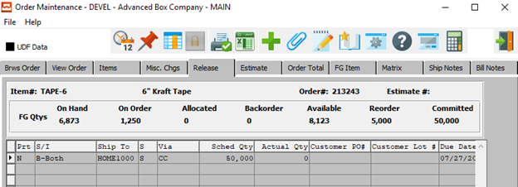

#### Add a Negative Release





#### BOL Alternative



The customer service representative processes a release just as a normal order except the quantity is negative. They can also simply click the “***BOL/INV”*** button directly from the order line item screen and bypass creating a release.

#### Advantages

The advantage of this process is the truck driver has a formal bill of lading document for picking up the returns goods.

For example, we ship 10 units at 1000 per pallet with tag numbered 1 to 10. Two units are returned by creating a negative release for 2000, which creates a bill of lading for negative 2 units at 1000 per unit with NO TAG Number. This in turn creates a negative invoice, thus updating the inventory with 2000 on hand without a blank tag number.

### Step Two: Print and Post Bill of Lading

Print the Bill of Lading and Post the Bill of lading.

#### Go to the Enter/Edit BOL [OS1] Folder

On the Bill of Lading Maintenance Browse Screen, highlight the selected Bill of Lading within the Browse list, and view detailed information on the *View Items* tab.

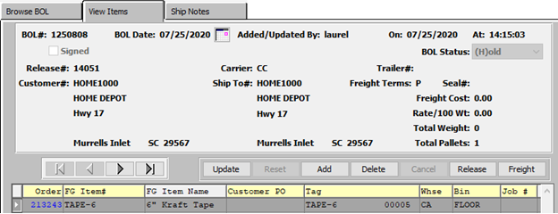

#### Print Bill of Lading

On the Print Bills of Lading [OS3] screen, choose the BOL Numbers to print.

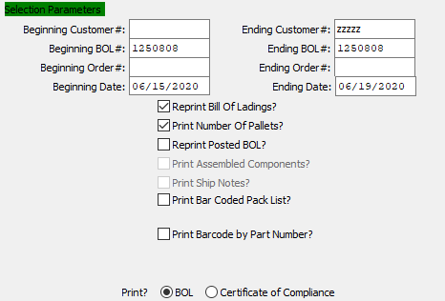

#### “N”-“K”-“1” BOLPOST Value

The inventory is adjusted depending on ***“N”-“K”-“1”*** BOLPOST logical Value.

When logical value = ‘*YES’*, posting the bill of lading for the negative release, the system posts a negative shipment which creates a positive finished goods balance with a blank load tag number, which is used for Sharp Shooter returns.

When N-K-1 BOLPOST logical value = ‘*NO’*, posting the bill of lading for the negative release, the system posts a negative shipment which creates a positive finished goods receipts with a blank load tag number and also and ALSO a negative receipt, which effectively has no effect on inventory. This option is best used to simply add Cycle Counts for returned Tags

### Step Three: Print and Post Invoice

The invoice is for a negative quantity times the sells price which is equivalent to a credit memo.

#### Go to the Invoice Maintenance [OB1] Folder

On the Invoice Maintenance Browse Screen, highlight the selected Invoice within the Browse list, and view detailed information on the *View Invoice* tab.

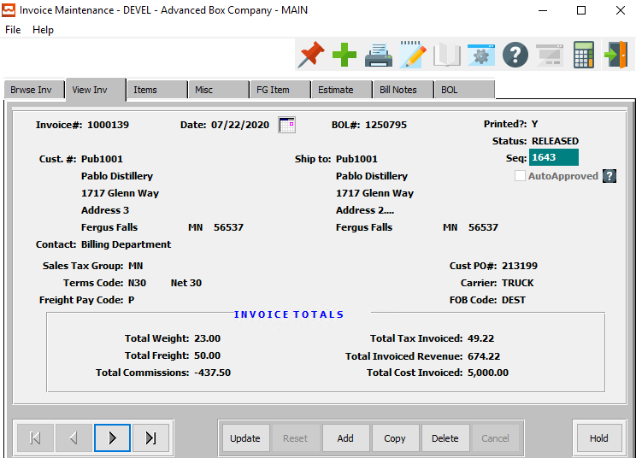

#### View Individual items

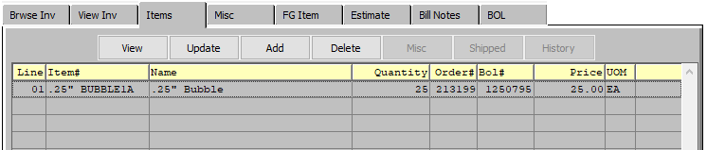

### Step Four: “N”-“K”-“1” BOLPOST Logical Value Inventory Control

#### “N”-“K”-“1” BOLPOST Value

Bill of Lading Shipments will subtract from inventory so a negative shipment will increase inventory.

***“N”-“K”-“1”*** BOLPOST Logical Value = ‘*NO’* will create both a Negative receipt and Negative Shipment which will equal ZERO On Hand

Whereas, ***“N”-“K”-“1”*** BOLPOST Logical Value = ‘*YES’* will only create a Negative Shipment which will increase the blank tags On Hand Quantity.

#### Finished Good History

The user may check on the current quantity and history of an item by browsing the item’s history in the *Finished Good Item Inventory [IF1]* system, on the *History* tab.

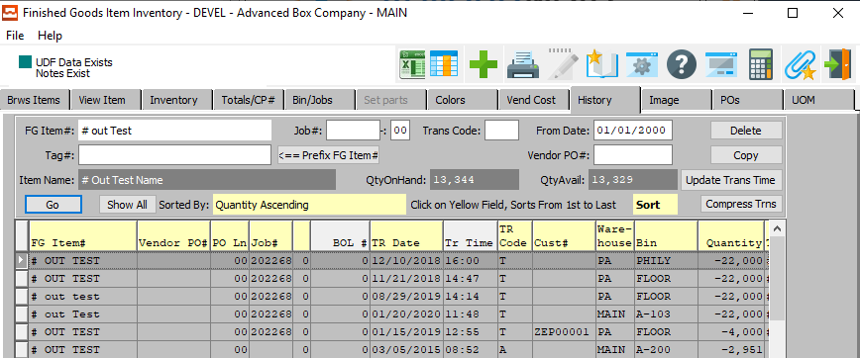

### Step Five: Cycle Count for Returns with Pallet Tags

This option is used when ***“N”-“K”-“1”*** BOLPOST Logical Value = ‘*NO’*, which creates a zero balance for the negative release.

This option creates a negative receipt for a blank tag that offsets the negative shipment which increase inventory for the blank tag. This assumes that the returned goods still have the original pallet tags on each pallet that is returned.

Therefore, this is the same logic as any other cycle count. For each pallet tag that is returned, the tag will cycle counted for the new quantity that will be returned to inventory.

#### Sharp Shooter: Finished Goods – Count Goods

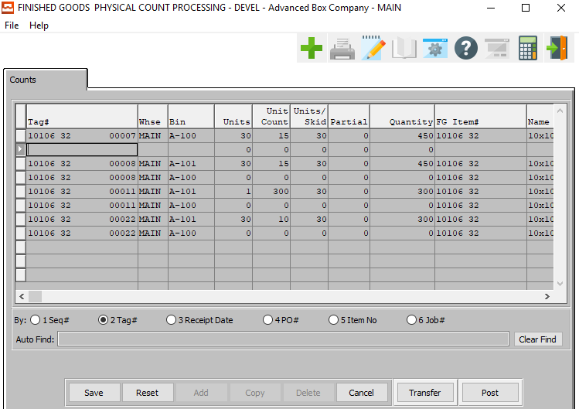

### Step Six: Load Tag Creation for Returns without Tags

This option is used when ***“N”-“K”-“1”*** BOLPOST Logical Value = ‘*YES’*, which created a blank tag with a positive balance equal to the negative release.

#### Go to the Loadtag Creation [OU7] Screen

The ***“O”-“U”-“7”*** Load Tag creation is used while checking the Toggle Box called RETURNS.

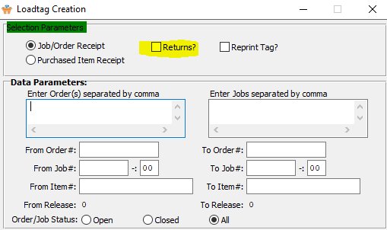

Normally, when ***“N”-“K”-“1”*** FGRECEIPT character value = LOADTAG, the load tag creation program will automatically create FG receipts for each load tag created. But this does not occur when the returns toggle box is checked.

Obviously, we do not want to create finished goods production receipts when we are just reworking the returns. Therefore, the Returns toggle box will not create a receipt quantity. The assumption is that the original finished goods load tags were already produced, and we are now just creating new load tags for the reworked finished goods.

In summary, this toggle box will prevent new finished goods receipts that would have created incorrect production totals.

#### Sharp Shooter Returns

Step One: Is to create Load Tags for the Returned Goods. This will prevent new Finished Goods receipts that would create incorrect production totals. The Returns toggle box simply creates the text file that is used to create the new load tags for the reworked pallet tags.

A negative release quantity and negative bill of lading will a create a positive Finished Goods receipt quantity without a tag number. The Sharp Shooter Returns will subtract from this blank tag quantity and add to the new load tags on hand. The net result is swapping load tag numbers.

### Step Seven: Posting Returns

This option is used when ***“N”-“K”-“1”*** BOLPOST Logical Value = ‘*YES’*, which created a blank tag with a positive balance equal to the negative release quantity.

#### Sharp Shooter: Return Goods

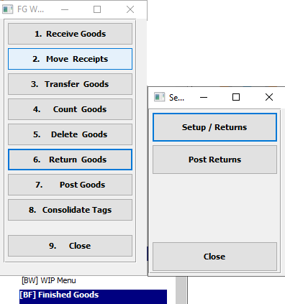

Posting Sharp Shooter “***RETURNED GOODS”*** will simultaneously increase the new Tag Quantity and decrease the Blank Tag created via the negative release. The “***F1”*** key will show only Load Tags that have not been received. This will show the load tags created but never received when creating the load tags with the Returns toggle box checked.

***“RETURNS”*** in Sharp Shooter finished goods provides for receiving the new load tags by reducing the finished goods bin location with a blank tag number. Therefore, the inventory created by the negative release will be reduced as each new load tag is scanned into the system via the Sharp Shooter Return Goods program.

#### Post Returns

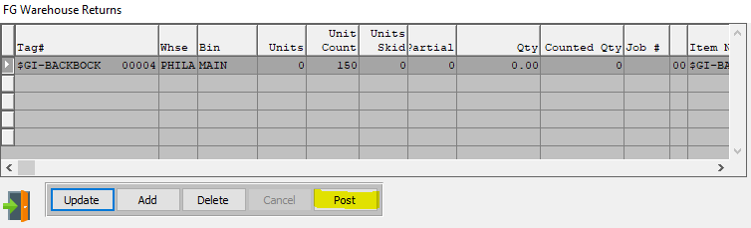

***“POST RETURNS”*** will post all of the selected returns within the Warehouse Returns list. It will first prompt the user to confirm that they wish to post the selected returns. If the user selects ***“Yes”***, then the system will automatically post the returns without any further input needed.

